Monday | Tuesday | Wednesday | Thursday | Friday
2 DYNGUS DAY | 3 | 4 ENTRÉE SALAD | 5 | 6
Cabbage Roll with Savory  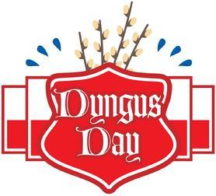  Sauce  Mashed Potatoes  Carrots  Ice Cream (723) | Breaded Chicken Breast with Mushroom Gravy  Butternut Squash  Green Beans w/ Red Pepper  Diced Pears (680) | Julienne Salad  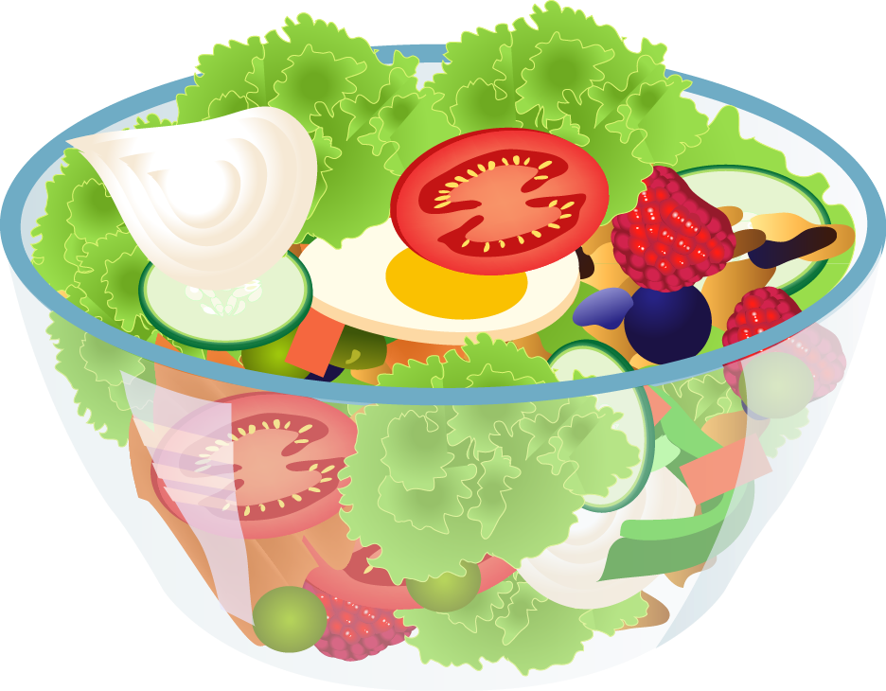  with Dressing  Rye Bread  Fresh Banana  (819) | Breaded Boneless Pork Chop with Gravy  Scalloped Potatoes  Cottage Mixed Vegetables  Ambrosia (903) | Hamburger with Onion Gravy  Oven Browned Potatoes with Peppers & Onions  Seasoned Spinach  Gelatin with Fruit (876)
9 | 10 Chef Side Salad | 11 | 12 | 13
BBQ Pulled Pork  Seasoned Home Fries  Romano Vegetable Blend  Fresh Orange  Chocolate Milk  (854) | Penne Pasta with Meatballs and Tomato Sauce  Peas  Chef Salad with Dressing  Tropical Fruit  (902) | Breaded Chicken Breast with Herb Gravy  Mashed Sweet Potatoes  Cauliflower  Chocolate Chip Cookies  (934) | Meatloaf with Onion Gravy  Mashed Potatoes  Fiesta Corn  Orange Pineapple Velvet  (937) | Breaded Fish with Tartar Sauce  Broccoli Cheese Rice Casserole  Carrots  Apple Juice  Frosted Brownie (869)
16 | 17 | 18 | 19 | 20
Boneless Chicken Breast with Gravy  Cheesy Mashed Potatoes  Peas  Butterscotch Pudding  (657) | Veal Parmesan with Tomato Sauce over Penne Pasta  Apple Juice  Seasoned Spinach  Carnival Sugar Cookies  (972) | Ham Steak with Maple Glaze  Mashed Sweet Potatoes  Green Beans with Red Pepper  Gelatin with Fruit  (689) | Hot Dog with Chili Sauce  Macaroni & Cheese  California Blend Vegetables  Pineapple Tidbits  (860) | Breaded Boneless Pork Chop with Gravy  Mashed Lyonnaise Potatoes  Broccoli  Fresh Banana  (696)
23 | 24 | 25 Chef Side Salad | 26 | 27 ENTRÉE SALAD
Swedish Meatballs over Cavatappi Pasta  Brussels Sprouts  Corn  Chocolate Pudding  (785) | Breaded Chicken Breast with Gravy  Mashed Sweet Potatoes  Green Beans  Tropical Fruit  (756) | Lasagna Roll with Tomato Meat Sauce & Mozzarella Cheese  Cauliflower  Chef Salad with Dressing  Strawberry Bavarian (968) | Turkey with Stuffing & Gravy  Sour Cream & Chive Mashed Potatoes  Carrots  Lemon Cake with Frosting  (808) | 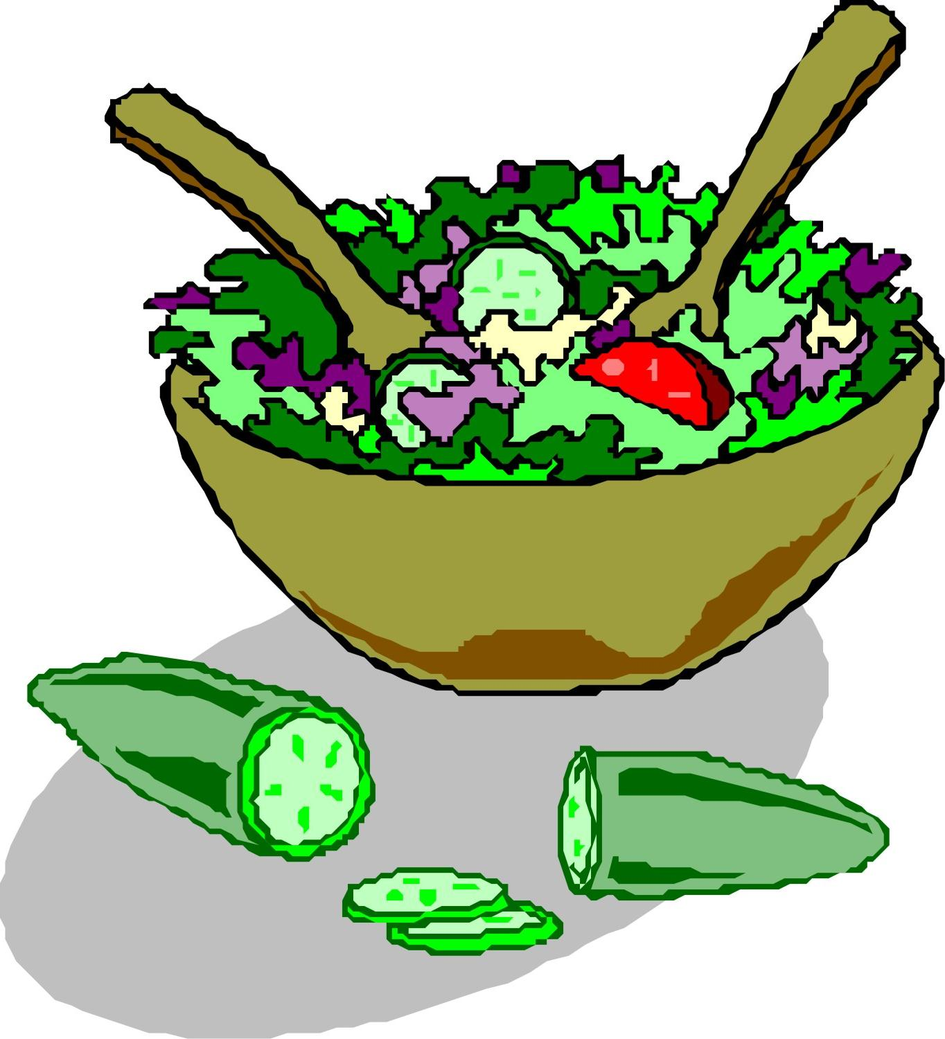  Julienne Salad  with Dressing  Wheat Dinner Roll  Fresh Orange  (795)
30 | 1 Chef Side Salad | 2 | 3 | 4
Beef Pepper Steak over Rice  Green Beans with Red Pepper  Carrots  Fruit Delight Cookie  (653) | Stuffed Shells with Tomato Sauce  Seasoned Spinach  Chef Salad with Dressing  Pineapple Tidbits  (988) | Boneless Chicken Breast with Gravy  Mashed Sweet Potatoes  Mixed Vegetables  Fresh Banana  Chocolate Milk (702) | Hot Roast Beef Sandwich on a Bun with Gravy  Garlic Mashed Potatoes  Stewed Tomatoes  Sugar Cookies  (813) | Ham & Cheese Strata with White Cheese Sauce  Scalloped Apples & Cranberries  Broccoli  Ambrosia  (947)

~ ORDER YOUR LUNCH TODAY ~

~ WEST SENECA SENOR CENTER 675-9288 ~

